Graph Theory – Classifying Graphs Name___________________Per___
A simple undirected weighted cyclic graph:
Graph: collection of vertices and edges
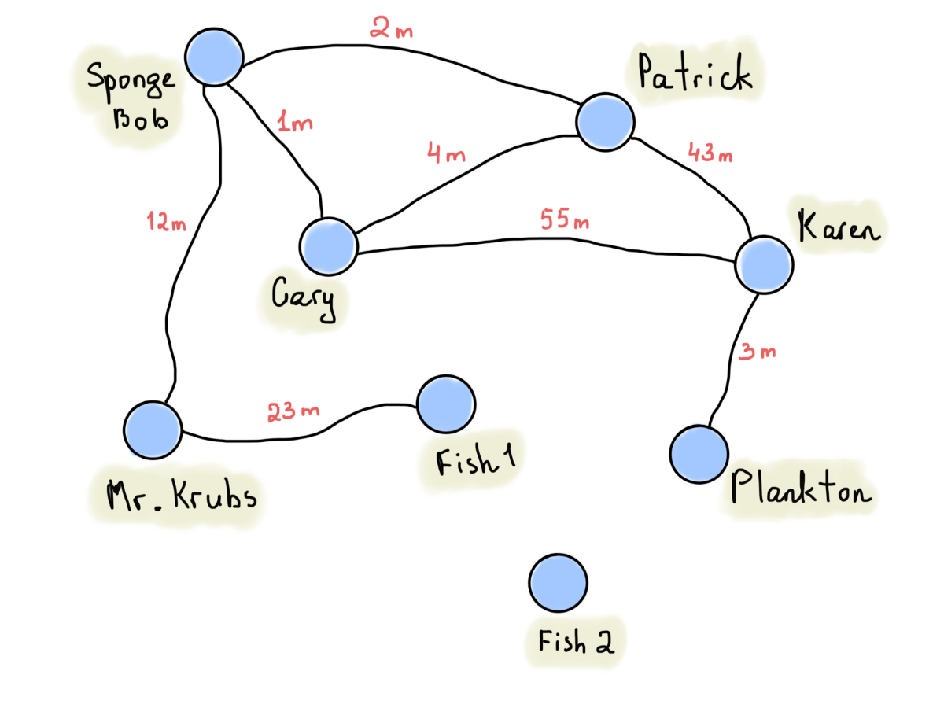
Path from x to y: list of vertices in which successive vertices are connected by edges: SB-MK-F1
Simple Path: a path in a graph which does not have repeating vertices (e.g. SpongeBob-Gary-Karen).
Cycle: a simple path of edges and vertices wherein a vertex is reachable from itself (e.g. Gary-Patrick-Karen-Gary).
Simple Graph: doesn’t contain multiple edges between nodes nor loops. A simple directed graph has no multiple arrows with same source and target nodes
Connected graph: path exists from every vertex to every other vertex
Unconnected graph: a graph that is not connected and is made up of connected components
Tree: An undirected graph in which any two vertices are connected by exactly one path.
I.e. a connected acyclic undirected graph. I.e. a connected graph that does not contain even a single cycle.
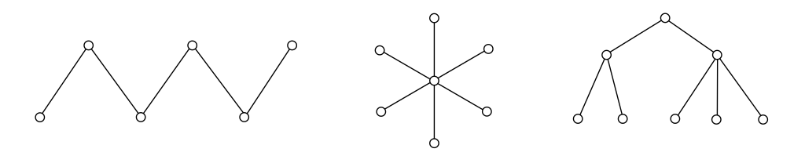
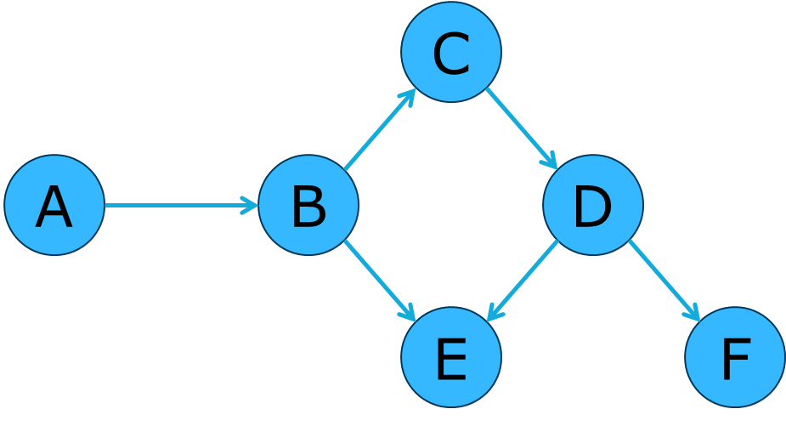
Directed Acyclic Graph (DAG):
a directed graph with no cycles

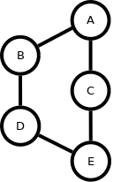
Cyclic Graph: A graph with at least one cycle.
Circular Graph: A graph that is a cycle.
Complete Graph: A simple graph in which each pair of distinct vertices are adjacent.
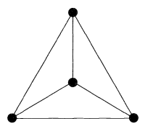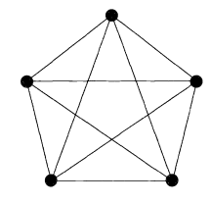
Adjacency matrix: matrix containing 1’s and 0’s indicating an existing directed edge between vertices.
1 = edge exists, 0 = edge does not exist

